IN FREEDOM
Words and Music by Aran Puddle

VERSE 1:
A rising generation
Set apart for liberty
A royal loving people
Chosen to be mighty
Mighty in the Land

VERSE 2:
A people who are hungry
hungry for the bread of life
A people who are thirsty
Thirsty for the river
The river of joy

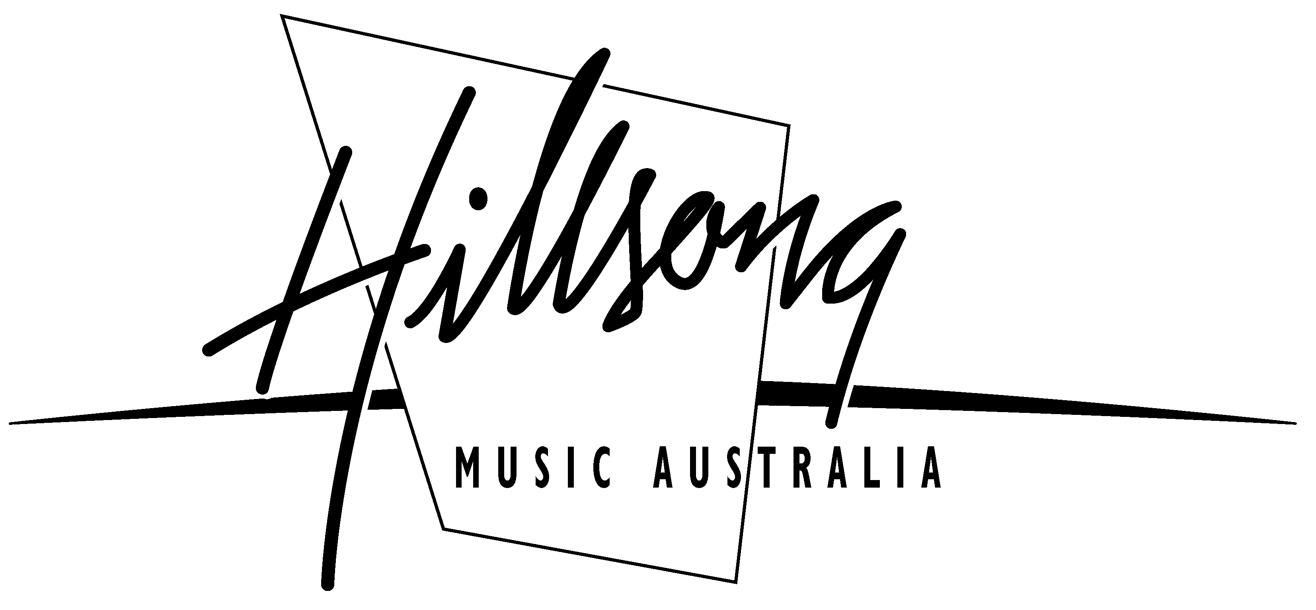 | © 1998 Aran Puddle / Hillsong Publishing  PO Box 1195 Castle Hill NSW 1765 Australia  Ph: 61 2 8853 5353 Fax: 61 2 9899 4591  Email: publishing@hillsong.com

In Freedom – Page 2

BRIDGE:
And all across this nation
A cry is ringing out
The church of the King’s breaking out

CHORUS:
In freedom
In power
In healing
Salvation to the ends of the earth

